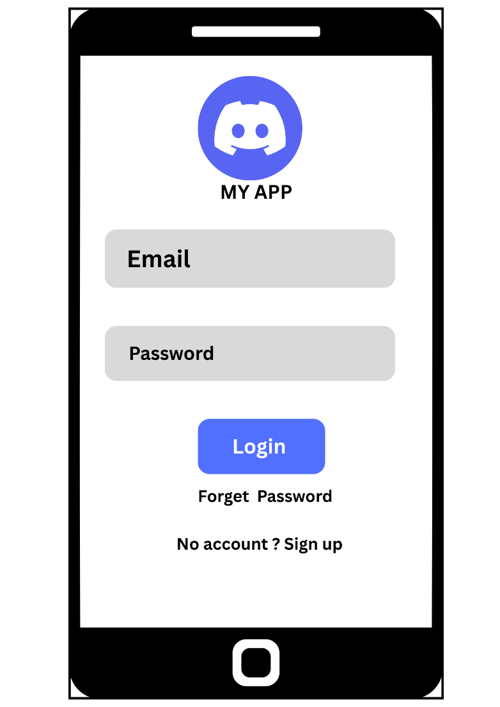

Explanation of My Wireframe Design
This login screen is designed with a simple and clean layout to improve user experience. The app logo and title are placed at the top so users can easily recognize the application. The email and password fields are large and clearly labeled, making them easy to read and use.
The login button is placed in the center with a highlighted color to attract user attention and make the main action clear. The “Forget Password” and “Sign Up” options are also included to help users recover accounts or create new accounts easily.
Proper spacing and alignment are used throughout the design to keep the interface readable and user-friendly. The overall wireframe follows a simple hierarchy so users can quickly understand and navigate the screen without confusion.

